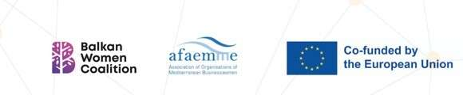

Number of Reference: 2023 -2 - EL01 - KA210 – ADU - 000170360

Digital Readiness Empowering Ambitious Middle-Aged
+45 Women Entrepreneurs
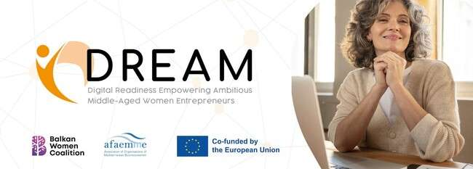

Greetings!
The DREAM Project is moving forward!
👋 Hello to all our wonderful readers!
We’re excited to share the ongoing journey of @Dream — Digital Readiness Empowering Ambitious Middle-Aged Women Entrepreneurs. This inspiring initiative continues to promote inclusion, digital innovation, and international collaboration for women aged 45 and over.
Supported by Erasmus+, the project focuses on a user-centered learning approach, offering practical, real-world examples to help women in Greece and Spain gain the digital skills they need to thrive as entrepreneurs.
Multiplier Event

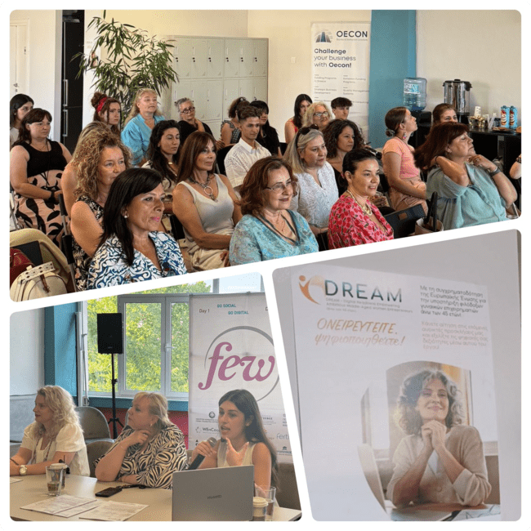

On Monday, the local Multiplier Event of the DREAM project took place with great success, from our partners from Balkan Women Coalition in Thessaloniki, Greece.
This Local Multiplier event included a presentation of the project, outlining its goals and accomplishments so far, as well as a brief introduction to the partner organizations was also presented. Participants had the chance to explore ways to strengthen their digital skills and receive updates on the project's upcoming activities and future plans.
✨ One of the most engaging parts of the event was the Living
Libraries activity — an open, interactive space where women had the chance to connect through meaningful dialogue, share personal stories, and gain insights into the next stages of the project. It offered a safe and inspiring environment for conversation, reflection, and connection.
The gathering brought together professionals, community members, and key stakeholders united by a shared mission: to foster inclusive spaces where women’s perspectives and skills are recognized, supported, and celebrated.

Local Training Session
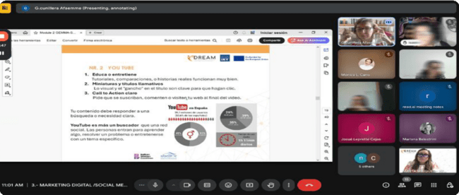

At the same time, we’re excited to announce that the @Dream: Digital Readiness Empowering Ambitious Middle-Aged Women Entrepreneurs project is conducting a very significant activity — local training sessions took place online in Spain and will soon be launched in Greece.
Specifically, our partners from AFAEMME in Spain have already conducted their local training sessions online with the participation of women entrepreneurs over 45+ who were interested to develop their digital skills.
Project Update from Barcelona! 🤝🇬🇷

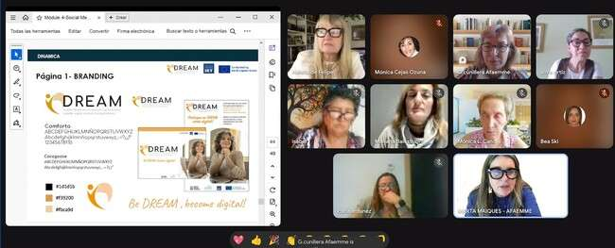

Local Training Sessions in BARCELONA! 🚀

In May-July, we held our online training sessions for Spanish participants. These sessions supported women aged 45+ in developing

entrepreneurial skills through digital tools.

We explored key topics such as personal branding (defining one’s identity, values, and ideal audience), digital marketing (developing strategies to promote services and effectively reach target markets), and social media (selecting the right platforms, planning content, and utilizing visual storytelling). Led by expert trainers, the sessions were highly interactive and rich in resources, providing practical guidance for participants at all levels. The approach combined theory with hands-on activities, enabling immediate application of the concepts covered.

On July 1st, a follow-up session deepened prior topics, supported collaboration, answered personal questions, and reviewed participants’ progress. The goal: not just to teach, but to empower women to build real, sustainable digital businesses.

Local training session in Greece!

The local training sessions in Greece will take place in the next few weeks and you should not miss your spot!
The dates for the Local Training Sessions are going to be announced soon, so stay updated!

The energy is incredible, the feedback has been truly encouraging, and our motivation to continue growing is stronger than ever.
A heartfelt thank you to everyone who’s contributed — we’re proud of how far we’ve come and even more enthusiastic about what lies ahead!

We’re looking forward to the final steps and can’t wait to see the positive impact this project will have on women across Europe! 🚀

Follow us on Social media or
👉 Visit our web https://thedreamproject.eu/

Any questions? Contact us: g.cunillera@afaemme.org info@balkancoalition.com

Co-funded by the European Union. Views and opinions expressed are however those of the author(s) only and do not necessarily reflect those of the European Union or the State Scholarships Foundation (IKY). Neither the European Union nor IKY can be held responsible for them.



DREAM PROJECT
https://thedreamproject.eu/

Any questions?
Contact g.cunillera@afaemme.org info@balkancoalition.com

AFAEMME
Provenza 301 local, 08037, Barcelona Ver en navegador | Cancelar suscripción

